THE GIRL WHO DRANK THE MOON

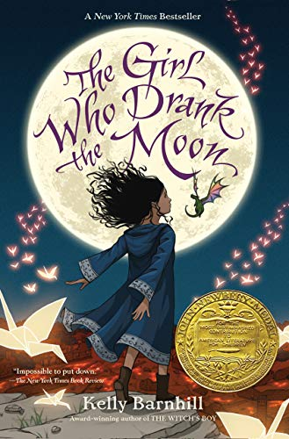

I avidly read fairy-tales because they are replete with folkloric characters (fairies, goblins, witches, giants, and many more), enchantments ineffable, and mysteries inconceivable! They infallibly cure hearts that have stopped believing in the power of goodness and miracles. Additionally, they attach morals to the plot, if not explicitly but subtly!  
  
Post finishing these magical books, the hearts overflow, with ideas of magic, ambitions of achieving the impossible , and smiles nestled with hope inculcated!  
  
They generally proclaim victory of good over evil, all the killings and cruelty are justified by acts of kindness, and kingdom of love thrives amidst all the treacherous and pernicious surroundings!  
  
And Bingo, for me **“The Girl who drank the moon”**, ticked all the departments of fantasy steadily!  
 **I am “enmagicked” post reading this incredible magnificent fantasy-piece!**  
  
It is an endearing, spell-binding, resplendent fairy-tale bursting with enchantment, moonlight, starlight, a baby dragon, a swamp monster, a good-hearted witch, an innocent playful baby and magic overflowing.  
  
Heroes are flawed who evolve into villains. The villains in the story are overflowing with emotions of humanity and love, they are the saviours of grace.  
  
This divergence from the regular, makes this work “enmagicked”!  
  
############################  
There is a Protectorate sitting between a hideous forest and a magnanimous Bog. The Protectorate populace lives in the constant fear of a wicked witch, Xan, who haunts the forest for new-born babies. She allows them to live in peace with the stipulation that they would annually sacrifice a new-born to her. Ironically, Xan turns out to be the hero of the novel, she is the one who is the saviour of all the babies, feeds them on starlight, rescues and mothers them, leaves them with neighbouring loving families of the village. Then we have a selfish Gherland, who is the leader to the Council of the Elders in the Protectorate. Gherland every year leaves a baby into the woods for Xan. This time the rescued baby is accidentally fed with moonlight instead of the starlight by Xan, and the child becomes “enmagicked”!  
  
As the child is growing, Xan realises that the baby is overflowing with magical powers, she names her Luna and decides to look after her and nurture her like a grandmother instead of abandoning her. She finds kinship in her. The story has a loving witch who is the HERO ! The swamp monster is a witty poet, and the playful little dragon imbues the plot with humor and intermittent bouts of laughter. Not revealing much to stay back from spoilers.  
  
############################  
There is much more magic to this fanciful, thrilling, compelling fairy-tale. There is obsequiousness coupled with fear, oppression bundled with selfishness and corruption. The ending is very satisfying, inundated with love!  
 *The novel is an exposition of voicing against the powerful, corruption and oppression. It is about building own families and nourishing them with unconditional love. It professes that heroes may be disguised as villains, and the heroes whom we idolise as saviours may be the persecutors!  
  
This book is thematic of kindness and cruelty, hope and despair, magic and menace, loss and tragedy, creating families and sprinkling love among all.*  
  
A definite and easy 5-star without an iota of doubt!  
  
Few of my favourite quotes from this book are:  
 **“Sorrow is dangerous.”  
  
“Knowledge is power, but it is a terrible power when it is hoarded and hidden.”  
  
“Just because you don't see something doesn't mean it isn't there. Some of the most wonderful things in the world are invisible. Trusting in invisible things makes them more powerful and wondrous.”  
  
“Everything you see is in the process of making or unmaking or dying or living. Everything is in a state of change.”  
  
“A story can tell the truth...but a story can also lie. Stories can bend and twist and obfuscate. Controlling stories is power indeed.”  
  
“Some of us...choose love over power. Indeed, most of us do.”  
  
“My love isn't divided," she said. "It is multiplied.”  
  
“When you apologize, however, you may begin healing yourself. It is not for us. It is for you. I recommend it.”  
  
“It was wrong not to be curious, it was wrong not to wonder.”  
  
“How many feelings can one heart hold? She looked at her grandmother. At her mother. At the man protecting his family. Infinite, Luna thought. The way the universe is infinite. It is light and dark and endless motion; it is space and time, and space within space, and time within time. And she knew: there is no limit to what the heart can carry.”**